Creating a new request to exchange data with server from behind the scenes

Var xhttp = new XMLHttpRequest()

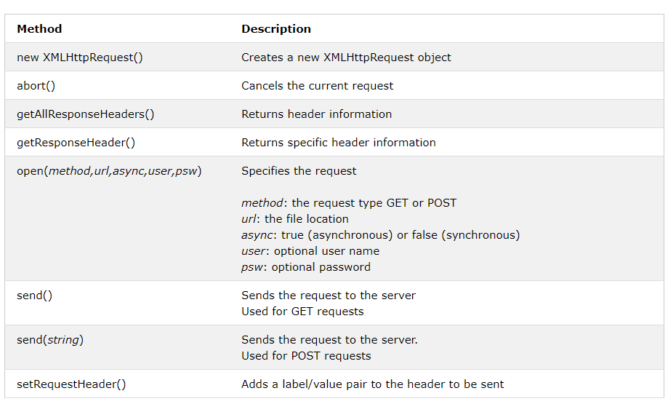

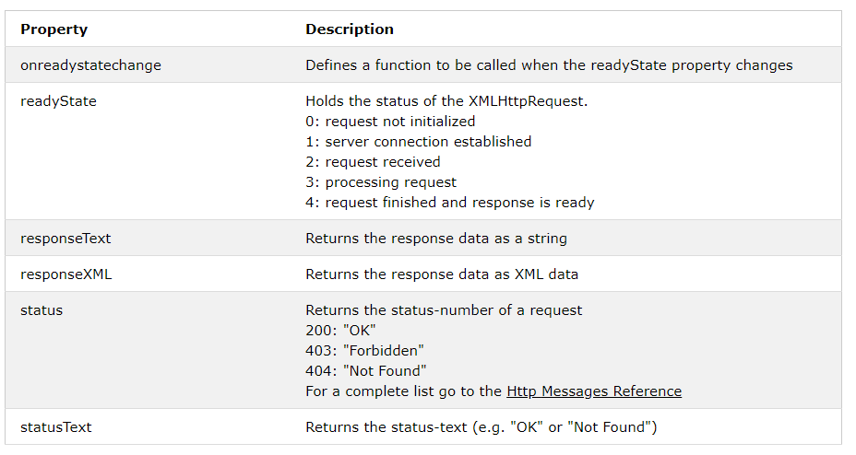

xhttp.open("GET", "ajax_info.txt", true);  
xhttp.send();

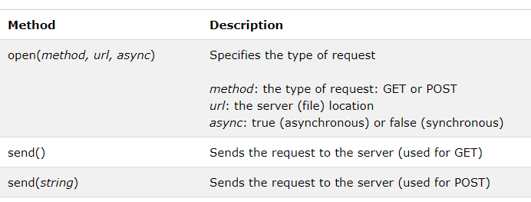

xhttp.onreadystatechange = function() {  
  if (this.readyState == 4 && this.status == 200) {  
    document.getElementById("demo").innerHTML = this.responseText;  
  }  
};  
xhttp.open("GET", "ajax_info.txt", true);  
xhttp.send();

Callback function : --

Use in case of more than 1 ajax task

loadDoc("url-1", myFunction1);  
  
loadDoc("url-2", myFunction2);  
  
function loadDoc(url, cFunction) {  
  var xhttp;  
  xhttp=new XMLHttpRequest();  
  xhttp.onreadystatechange = function() {  
    if (this.readyState == 4 && this.status == 200) {  
      cFunction(this);  
    }  
 };  
  xhttp.open("GET", url, true);  
  xhttp.send();  
}  
  
function myFunction1(xhttp) {  
  // action goes here  
}   
function myFunction2(xhttp) {  
  // action goes here  
}

getting header response

var xhttp = new XMLHttpRequest();  
xhttp.onreadystatechange = function() {  
  if (this.readyState == 4 && this.status == 200) {  
    document.getElementById("demo").innerHTML =  
    this.getResponseHeader("Last-Modified");  
  }  
};  
xhttp.open("GET", "ajax_info.txt", true);  
xhttp.send();

Reading an xml file through loadxmldoc()

function loadDoc() {  
  var xhttp = new XMLHttpRequest();  
  xhttp.onreadystatechange = function() {  
    if (this.readyState == 4 && this.status == 200) {  
    myFunction(this);  
    }  
  };  
  xhttp.open("GET", "cd_catalog.xml", true);  
  xhttp.send();  
}  
function myFunction(xml) {  
  var i;  
  var xmlDoc = xml.responseXML;  
  var table="<tr><th>Title</th><th>Artist</th></tr>";  
  var x = xmlDoc.getElementsByTagName("CD");  
  for (i = 0; i <x.length; i++) {   
    table += "<tr><td>" +  
    x[i].getElementsByTagName("TITLE")[0].childNodes[0].nodeValue +  
    "</td><td>" +  
    x[i].getElementsByTagName("ARTIST")[0].childNodes[0].nodeValue +  
    "</td></tr>";  
  }  
  document.getElementById("demo").innerHTML = table;  
}

DOM

Text is always stored in text nodes

<?xml version="1.0" encoding="UTF-8"?>  
<bookstore>  
  <book category="cooking">  
    <title lang="en">Everyday Italian</title>  
    <author>Giada De Laurentiis</author>  
    <year>2005</year>  
    <price>30.00</price>  
  </book>  
  <book category="children">  
    <title lang="en">Harry Potter</title>  
    <author>J K. Rowling</author>  
    <year>2005</year>  
    <price>29.99</price>  
  </book>  
  <book category="web">  
    <title lang="en">XQuery Kick Start</title>  
    <author>James McGovern</author>  
    <author>Per Bothner</author>  
    <author>Kurt Cagle</author>  
    <author>James Linn</author>  
    <author>Vaidyanathan Nagarajan</author>  
    <year>2003</year>  
    <price>49.99</price>  
  </book>  
  <book category="web" cover="paperback">  
    <title lang="en">Learning XML</title>  
    <author>Erik T. Ray</author>  
    <year>2003</year>  
    <price>39.95</price>  
  </book>  
</bookstore>

Example : --

**<year>2005</year>**

A node can be accessed in 3 ways : --

1. By using getElementsByTagName()
2. Looping
3. Using node relationships

*node*.getElementsByTagName(*"tagname"*);

Accessing a specific elements

x = xmlDoc.getElementsByTagName("title");

y = x[2];

using ngrok to create a channel